GHD Auto Time Entry User Guide

**Overview:**

The Auto Time Entry app is a tool for automating most of the time entry for GHD engineers (or other users of Zendesk and SAP). It converts the excel timesheets produced by Zendesk into a format compatible with SAP, then automatically enters the data into SAP.

**Usage:**

Requirements:

1. You are signed into SAP and on a time entry page
2. You have selected the top left cell in the time entry sheet

Process:

1. Run either the main.py or main.pyc (no console window) from the “app” folder (and make a desktop shortcut)
2. From the app screen, select your time sheet with the select time data button.
3. Select your name or whatever username you are filling time in for
4. Select the applicable week you wish to enter
5. Select how many sheet rows your SAP displays (see rows per page config)
6. Select whether you want to clear the existing data on the SAP page
7. Select whether you need the function button (see fn button config)
8. Press the run button.

Special cases:

Early stopping: if you wish to stop the time entry process while it is going, press the stop button in the app.

**Configuration:**

Select Time Data:

This button opens a file dialog that will allow you to select the Zendesk sheet to be used. Once a sheet is selected, the adjacent label should display the full path of the file. Selecting a file will enable other configuration options and the run button.

Select Name:

This dropdown will populate with all of the updater names in the selected sheet whenever the selected sheet is changed. You can use this to select which user will have their time entered.

Select Week: 

This dropdown will populate with all the available weeks in the provided spreadsheet. The weeks are in the format, Monday to Sunday (how SAP represents weeks) and correspond with the week in SAP. Only weeks with information will be populated. If you do not have time for a week (ex: on vacation) then you will not have that week as an option.

**You must select the correct week from the dropdown for the SAP week you are on**

This selector indicates how many SAP rows are on your screen when you are in the SAP time sheet. The example below indicates the relationship. This value can change depending on the size and resolution of your window.Table

**It is important to accurately select your displayed number of rows.**

Clear Existing Data: 

When this is selected, it will clear the data that is inside the SAP page you are on.

Use Function button: 

On some machines, the function keys by are bound to hardware functions by default (ex: changing the volume, screen brightness etc.) and use of the real function keys is required. If this is the case check this box.

Configure Columns button:

This button will open the Configure Columns window, where you can specify your SAP column layout. If you have not hidden or rearranged any columns in SAP, you can probably ignore this feature, though keep in mind that hiding unneeded columns will reduce the time that the entry takes.

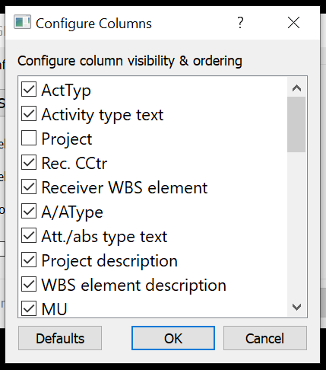Configure Columns window:

This window initially displays each of the SAP columns in their default ordering.

A checked column name indicates that the column is visible in SAP (you haven’t hidden it), while an unchecked column indicates one that has been hidden.

The checkbox does **not** represent whether a column is interactable (you can type in it). The intractability of each column is currently hard coded into the app.

You can drag and drop the column names to rearrange them to match your custom ordering.

The “Defaults” button will revert the columns to their default ordering and visibility.

Press the OK button to confirm your changes. Press the Cancel button to revert them.

**The project column is hidden by default and follows the “Activity type text” field**

**At this time, please do not put a non-interactable column as the first column.**

**Limitations:**

* In Zendesk, you currently can only enter time for the current date. For example, if you worked some time on Tuesday, but entered that time into Zendesk on Wednesday, the time will be attributed to Wednesday.
* There are some cases where unpredictable lag in the SAP application may cause the Auto Entry AI to become misaligned. I have tried to eliminate as many of these cases as possible, but some may remain. If the app appears to become misaligned, please stop the app with the stop button and try again (selecting the “clear existing data” option and starting from the top-left row again).
* Focusing another window while the app is running will prevent it from sending key commands. This has the effect of pausing the app until the SAP window is made the focus again, but it may also occasionally cause misalignments. At this time, I would advise against taking any actions on your screen while the app is running unless you intend to stop the app.